10th March 2017

**YOKOHAMA Tyres to Come Factory-Equipped on New Toyota Vitz/Yaris**

YOKOHAMA announced today that it has begun supplying tyres to Toyota Motor Corporation as original equipment for the automaker’s all-new Vitz (for Japanese market)/Yaris (for other markets), which was launched on January 12. The new Vitz/Yaris, being sold in Japan, Australia and New Zealand, comes equipped with one of three YOKOHAMA tyres – the “YOKOHAMA dB E70” (tyre size = 195/50R16 84V), the “BluEarth E70” (175/70R14 84S) or the “S73” (165/70R14 81S).

The “YOKOHAMA dB E70” is an OE tyre that was developed with an emphasis on quietness. In addition to providing a highly quiet ride, the “YOKOHAMA dB E70” is a highly rigid tyre that delivers superior stability and a comfortable ride while contributing to the vehicle’s low fuel consumption. The “BluEarth E70” and the “S73” feature the basic design and materials technology used in the Yokohama Rubber’s “BluEarth” global tyre brand, which is based on the concept of “environmentally, human, and socially friendly”. The tyres deliver a safe, comfortable ride while enhancing the vehicle’s fuel efficiency. They are ideal summer tyres for passenger cars.

YOKOHAMA is aggressively developing tyres employing its leading-edge “BluEarth” tyre technology, and many of these tyres have been adopted by automakers as original equipment, especially on new eco cars and hybrid vehicles.

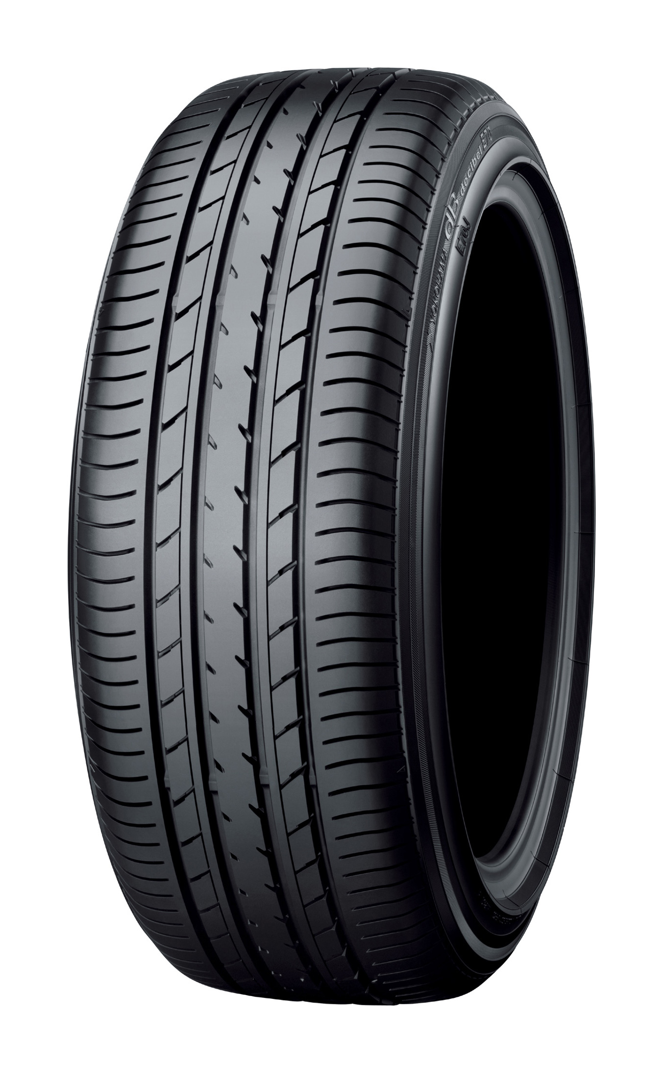

*YOKOHAMA dB E70 Size shown is different from those used as OE on Toyota’s Vitz/Yaris*

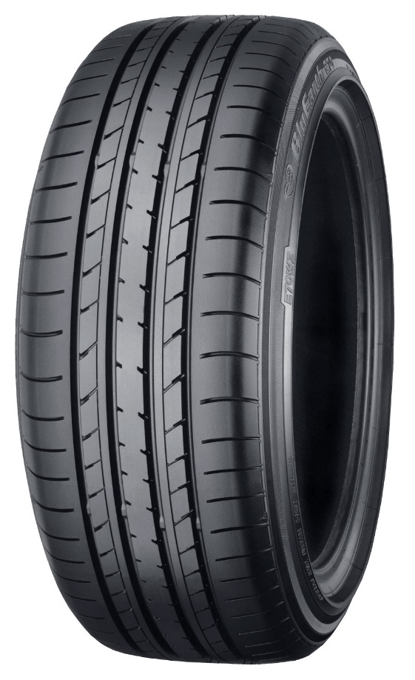

*BluEarth E70 Size shown is different from those used as OE on Toyota’s Vitz/Yaris*

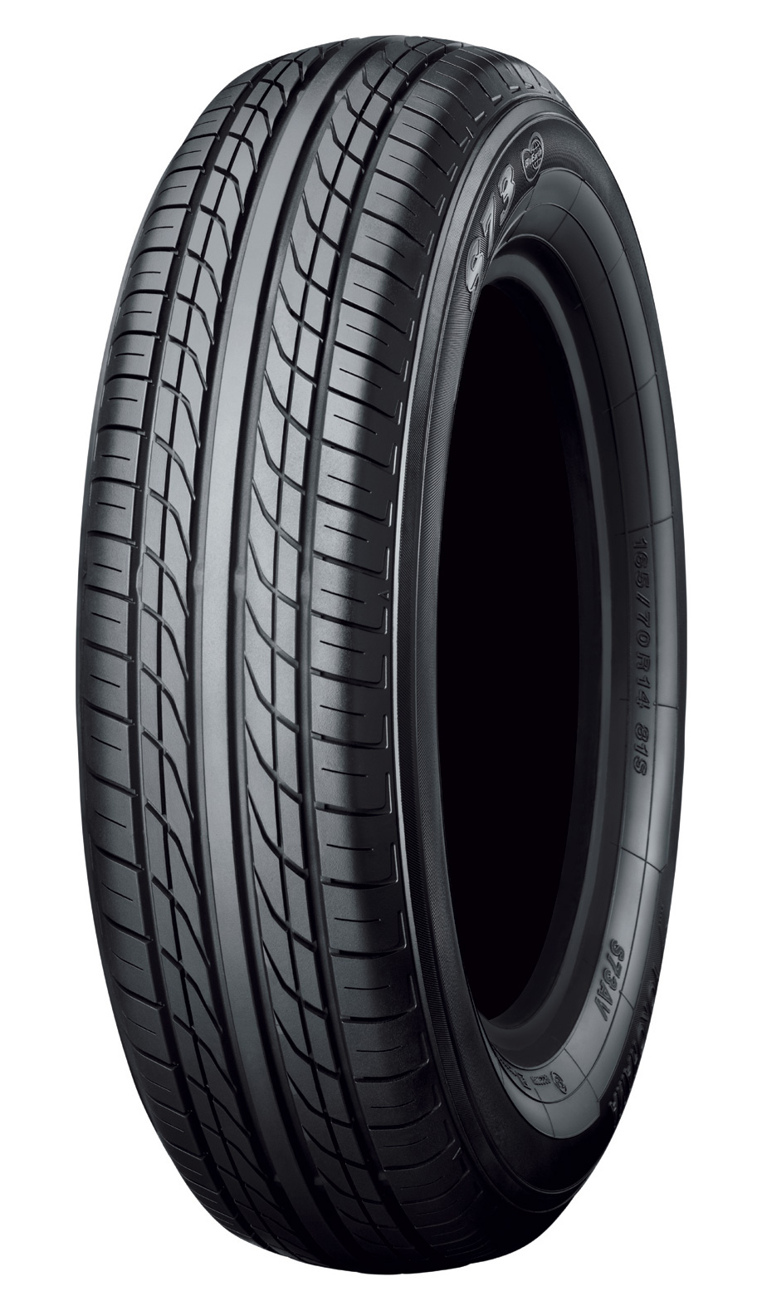

*S73 Size shown is different from those used as OE on Toyota’s Vitz/Yaris*